VISVESVARAYA TECHNOLOGICAL UNIVERSITY
Jnana Sangama, Belgaum-590018

A PROJECT REPORT (BAD786)/(BCD786) ON
“Flutter-Powered Smart Attendance System Using InsightFace”
Submitted in Partial fulfillment of the Requirements for the Degree of
Bachelor of Engineering in Artificial Intelligence & Data Science OR CSE Data Science
By

AKASH BC (1CR22AD006) AVANTIKA GUPTA (1CR22AD016)
K CHARANI SAI REDDY(1CR22AD057)
YOGEESHA E (1CR22AD127)
Under the Guidance of, Asst Prof Rencita M Colaco, Dept. of AI&DS


DEPARTMENT OF ARTIFICIAL INTELLIGENCE & DATA SCIENCE CMR INSTITUTE OF TECHNOLOGY
#132, AECS LAYOUT, IT PARK ROAD, KUNDALAHALLI, BANGALORE-560037

CMR INSTITUTE OF TECHNOLOGY
#132, AECS LAYOUT, IT PARK ROAD, KUNDALAHALLI, BANGALORE-560037
DEPARTMENT OF ARTIFICIAL INTELLIGENCE& DATASCIENCE


CERTIFICATE
Certified that the project work entitled “Flutter-Powered Smart Attendance System Using InsightFace” carried out by Mr. AKASH BC, USN 1CR22AD006, Ms. AVANTIKA GUPTA, USN 1CR22AD016, Ms. KONDREDDY CHARANI SAI REDDY, USN 1CR22AD057, Mr. YOGEESHA E, USN 1CR22AD127, bonafide students of CMR Institute of Technology, in partial fulfillment for the award of Bachelor of Engineering in Artificial Intelligence & Data Science of the Visveswaraya Technological University, Belgaum during the year 2025-2026. It is certified that all corrections/suggestions indicated for Internal Assessment have been incorporated in the Report deposited in the departmental library.
The project report has been approved as it satisfies the academic requirements in respect of Project work prescribed for the said Degree.
.

GUIDE
Asst.Prof Rencita M Colaco Dept. of AI&DS, CMRIT
Dr. Shanthi. M.B. Professor & Head Dept. of AI&DS, CMRIT
Dr. Sanjay Jain Principal CMRIT

External Viva
Name of the Examiners Signature with Date
1.

2.

We, the students of Artificial Intelligence & Data Science, CMR Institute of Technology, Bangalore declare that the work entitled "Flutter-Powered Smart Attendance System Using InsightFace" has been successfully completed under the guidance of Asst Prof Rencita M Colaco, Artificial Intelligence & Data Science Department, CMR Institute of Technology, Bangalore. This dissertation work is submitted in partial fulfillment of the requirements for the award of Degree of Bachelor of Engineering in Artificial Intelligence & Data Science during the academic year 2025 - 2026. Further, the matter embodied in the project report has not been submitted previously by anybody for the award of any degree or diploma to any university.

Place: Bengaluru Date:
Team members Signature

AKASH BC (1CR22AD006)
AVANTIKA GUPTA (1CR22AD016)
K CHARANI SAI REDDY (1CR22AD057)
YOGEESHA E (1CR22AD127)

Attendance management is a critical task in academic institutions and workplaces, yet conventional methods such as manual roll calls or biometric systems are often time-consuming, error-prone, and susceptible to malpractice. This project proposes a Face Recognition-based Smart Attendance System that leverages deep learning and mobile technologies to achieve efficient, accurate, and secure attendance tracking.
The system is developed using a Flutter-based mobile application as the user interface, integrated with a Flask backend server that employs the InsightFace model for facial recognition. Student face embeddings are generated and stored during the training phase, and subsequent recognition is performed by comparing live classroom images against the stored embeddings. Recognized students are automatically marked present, with records stored in structured CSV files and synchronized with Firebase for authentication and data management. A manual override feature is also provided, enabling teachers to verify or update attendance where necessary.
By combining artificial intelligence with mobile computing, the proposed solution minimizes human intervention, reduces the likelihood of proxy attendance, and significantly accelerates the attendance-marking process. The system demonstrates high scalability, adaptability, and reliability, making it suitable for deployment in educational institutions as well as corporate environments seeking automation in workforce management.

I take this opportunity to express my sincere gratitude and respect to CMR Institute of Technology, Bengaluru for providing me a platform to pursue my studies and carry out my final year project.
I have a great pleasure in expressing my deep sense of gratitude to Dr. Sanjay Jain, Principal, CMRIT, Bangalore, for his constant encouragement.
I would like to thank Dr. Shanthi. M.B., Professor and Head, Department of Artificial Intelligence & Data Science, CMRIT, Bangalore, who has been a constant support and encouragement throughout the course of this project.
I consider it a privilege and honor to express my sincere gratitude to my guide Ms. Rencita M Colaco , Teaching Assistant, Department of Artificial Intelligence & Data Science, for the valuable guidance throughout the tenure of this review.
I also extend my thanks to all the faculty of Artificial Intelligence & Data Science who directly or indirectly encouraged me.
Finally, I would like to thank my parents and friends for all their moral support they have given me during the completion of this work.

 | TABLE OF CONTENTS
CONTENT |  | Page No.
Certificate Declaration Abstract Acknowledgement Table of contents List of Figures  List of Abbreviations |  | ii iii iv v vi viii  ix

INTRODUCTION
  - Problem Statement
  - Objectives
  - Relavance of Problem
  - Software development tool
  - Chapter wise summary
- Literature Survey
  - 1 paper
  - 2 paper
2.2 3 paper
- Proposed Model
  - architecture design
  - use case design
  - System flow design
- Implementation
- Results and Screenshots
  - login
  - Input
- Testing
7. Conclusion and Future scope

REFERENCES
APPENDIX

LIST OF FIGURES
Page No.
Fig 3.1 Flow-Chart 12
Fig 4.1 Home-Page 14
Fig 4.2 Resultant Output 14
Fig 4.3 Web Scrapped Data 15

LIST OF TABLES
Table Name Page No.

LIST OF ABBREVIATIONS

ML MACHINE LEARNING
KMC K-MEANS CLUSTERING

CHAPTER 1

INTRODUCTION

Problem Statement
Goal of the Project:

Objectives

CHAPTER 2

CHAPTER 3

    - .

IMPLEMENTATION

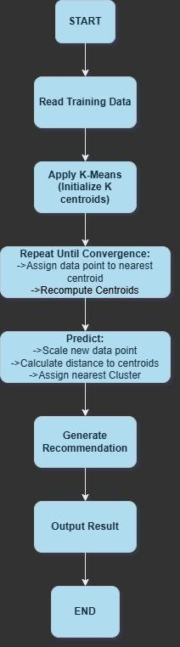

Fig 3.1 Flow-Chart

CHAPTER 4

RESULTS AND DISCUSSION

1.1 OUTPUT
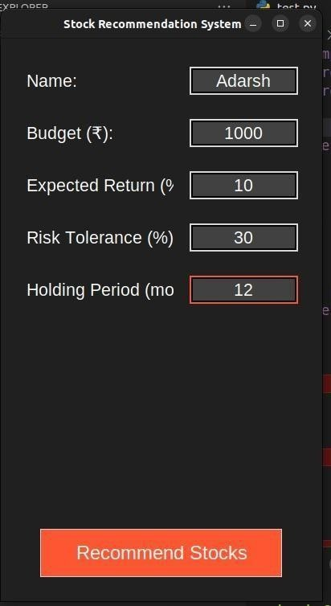
Fig 4.1 Home-Page

This homepage serves as an entry point for the STOCKS RECOMMENDER WITH ML platform, prompting users to select their role: Name, Budget, Expected Return, Risk Tolerance, Holding Period(months), enabling tailored access for stocks prediction. It ensures a user-friendly interface with a clean design for easy navigation
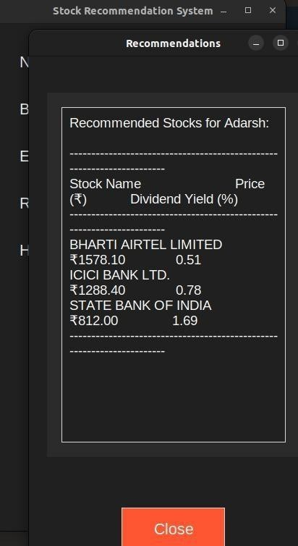
Fig 4.2 Resultant output

The result provides with the name of the stock , prices and the dividend yield(%).
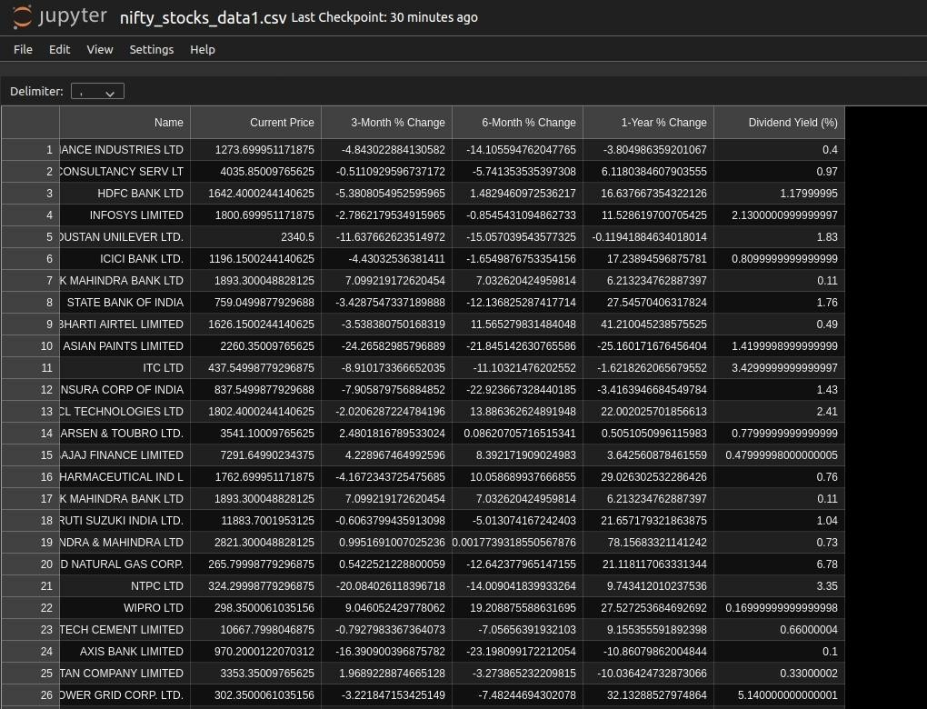
Fig 4.3 Web scrapped data

CHAPTER 5
TESTING

CHAPTER 6

CONCLUSION AND FUTURE SCOPE

CONCLUSION
    - esentation of stock clusters and trends.

CHAPTER 7
REFERENCES
- https://pypi.org/project/yfinance/

- https://scikit-learn.org/stable/

- https://kite.trade/docs/connect/v3/historical/

- https://scikit-learn.org/1.5/modules/generated/sklearn.cluster.KMeans.html

- https://x.com/cneuralnetwork

- https://x.com/novasarc01

APPENDIX

DATASETS
Stocks :- WEB SCRAPPED DATASET

